Evergood Wine Pouch Filling Automation Project

Engineering Specification Report

|  |  |
| --- | --- |
| **UCCS Senior Design Members** | **Project Sponsor and Faculty Advisors** |
| Ryan Beckman | Matthew Hexter |
| Brock Martin | Dr. Lynnane George |
| Hayden Mclaughlin | Dr. Bill Michaels |
| Jackson Taylor |  |
| Grace Wenham |  |

**Introduction**

Evergood Adventure Wines (“Customer”) is a craft winery located in Palmer Lake. The company makes wine from lemons and is distributed to over 250 locations throughout Colorado. Evergood was launched in 2018 and is reliant on volunteers to pouch their best-selling and seasonally sold wine, Heart Warmer. However, over 6,000 units are projected to be sold in 2022 and the current volunteer pouching system limits the supply of this product, limiting sales and company growth.

The current pouching process requires teams of 4-8 volunteers to work for a two-hour shift, during which they are compensated for their efforts with complimentary Evergood wine. One person sticks the printed labels onto blank pouches. Another will transport these pouches to the table where other volunteers can access them for wine filling, as well as take the filled wine pouches and put them in boxes to be sold. A third volunteer is responsible for opening the pouches with Nitrogen gas by operating a valve on a tube attached to a container of the gas.

The rest of the volunteers sit or stand at tables where they have their own Astrofill pouch holder, as pictured in Appendix A. This is a small metal stand which has a slot for the opening of the pouch to slide into and be secured to await filling. The pouch opening is held by this metal stand at a horizontal angle to minimize spillage. After opening the pouch with a puff of Nitrogen gas, the volunteer will insert a tube connected to the wine source and switch a valve to allow wine to flow into the pouch until it is within the acceptable range of weights. The wine source is in the center of the tables, being held in the air on a forklift to take advantage of gravity to carry the wine down from the source and into the pouches, pictured in Appendix A. After filling the pouch and applying force to snap the lid on the now-full pouch, the volunteer will wipe away any wine spillage with a wet rag.

The Customer has recruited the UCCS MAE Senior Design Team to create an automated wine pouch filling machine to decrease reliance on volunteers and increase output of wine pouches. The machine will increase production output and efficiency. Current solutions only offer semi-automatic filling, so the goal of this project is to automate this process as much as possible. Attention to guidelines and standards in place according to the Federal Drug Administration (FDA) and Bureau of Alcohol, Tobacco, Firearms and Explosives (ATF) shall be strictly monitored and followed in the creation of this design. The machine shall be built with the specific requirements detailed below.

**Problem Specification**

The project requirements originated from several sources, such as the customer, the government and other derived requirements such as those based on usability. The customer owns equipment such as nozzles, tubes, Astrofill stations and Nitrogen gas containers that they have encouraged us to incorporate into our design, which is another source of some specifications. The customer also specified several low-priority features that are not required but would increase the value of the prototype if they were included. Requirements mandated by the Government include the safety regulations set by the Food and Drug Administration (FDA), the Alcohol and Tobacco Tax and Trade Bureau (TTB), the American National Standards Institute (ANSI) and the Bureau of Alcohol, Tobacco, Firearms and Explosives (ATF). The following requirements are listed in order of importance:

1. Safe
2. Compliant with all FDA, TTB, ANSI, and ATF regulations
3. Requires two or less users to operate
4. Can perform the following operations:
   1. Able to accommodate Astrapouches
   2. Open pouch with puff of Nitrogen gas
   3. Fill pouch to user-specified volume/weight
   4. Seals pouch
5. Settings are adjustable
6. Durable and maintainable
7. Portable/easily maneuverable
8. Costs less than $30,000
9. Results in higher output of wine pouches than current volunteer-based pouching method

Safety is the highest priority ranking because Evergood is an ethical business who values the well-being of their employees and volunteers. They would not consider any solution to their problem which resulted in unsafe conditions.

Compliance with government standards is ranked next because some regulations are in place for safety reasons and some are in place for legal reasons, all of which Evergood must follow if they hope to be able to sell their product.

Next is the personnel limit of two users. This requirement is set because Evergood’s current dependency on volunteers limits their output of wine and by consequence also limits the growth of the business. The solution must only require two users maximum in order to remove this dependency on volunteers so the customer can operate their pouching machine whenever they have wine to pouch.

If the previous three conditions are met, the customer has only specified a few functions that the machine must be able to accomplish. This includes opening the pouch with a puff of Nitrogen gas, fill the pouch with wine, and seal the pouch with the cap provided. The customer has added that there are a few other functions that would be nice to have if time allows, but these three are the only ones that are explicitly defined. Details on these requirements are provided in the specifications and justifications section of this report. Also included is the requirement of being able to accommodate Astrapouches. This was specified because Astrapouches are the chosen brand for Evergood’s wine pouches, thus the solution must incorporate the wine pouches into the design and enable the use of them. If the solution could not accommodate Astrapouches, it would be rendered useless to Evergood.

The adjustable-settings requirement was created to allow the customer to adjust nearly all automated functions of the machine to allow for different sized pouches, different flowrates, or different pressures. The customer wishes to be able to change these to maximize the potential of the machine and continue using it in the future when certain variables may change. This requirement encompasses the need for the machine to be user-friendly because any user must be able to adjust the settings in order for it to be of use. Since UCCS is not affiliated with Evergood Wine, the customer must know how to use and adjust the machine after this Senior Design Group graduates and disperses because this team will not be able to assist after this year.

Another requirement is durability. This requirement ensures that the customer will be making a good investment in this project and that the product will serve them for years to come, allowing Evergood to grow as a business.

Next, the prototype must be portable and easily maneuverable. The current canning machine that the customer has is typically stored in the corner of the facility and rolled to the middle of the facility for operation, so this product must be created in a way that allows for this movement as well.

Then, the customer has expressed that cost is not of major importance to him as long as cost and efficiency are being optimized. As such, a $30,000 maximum cost has been allotted to the project, as explained more in the justification section of this report.

Last, the solution must be more efficient than the current volunteer-based system. The Customer has ranked this last because the main goal is to create a solution that eliminates the dependency on volunteers and the Customer understands that a single machine may not be able to outperform 4-8 volunteers in a matter of a few hours. However, the machine will be of greater importance in the long run because the Customer will be able to operate the machine themselves whenever they want and hence can produce more product throughout the week (whereas the volunteer-based system only operates on the weekends for a few hours at a time).

The following engineering specifications have been created to measure success in achieving the requirements described above. These specifications are organized in the following categories: regulatory, safety, material/cleaning/maintenance, personnel, calibration, usage, material cost, use of additional equipment and additional features specifications.

**Regulatory Specifications**

* The parts of the prototype that may come in contact with wine shall be made of components that are GRAS (Generally Recognized As Safe) according to the FDA
* The prototype shall fill within a percentage error of the target amount, as defined by the Alcohol and Tobacco Tax and Trade Bureau (TTB):
  + 750mL
    - Acceptable range: 2% or 735mL – 765mL
  + 1.5mL
  + Acceptable range: 1.5% or 1.4775L – 1.5225L

**Safety Specifications**

* Mechanisms that can: catch, pinch, smash, cut, or otherwise harm personnel that operate machinery shall be shielded from personnel.
* All electronics shall be sealed to the IP65 standard or be above cleaning height (height of the wine filling nozzle) to avoid electrical shock.

**Material/Cleaning and Maintenance Specifications**

* The prototype shall be constructed of materials that:
  + Are durable (able to hold 1.5kg pouches without deforming)
  + Can withstand hot water (up to 100°C) for parts that may encounter wine spillage
  + Can withstand PBW cleaner (Powdered Brewery Wash is an alkali-based cleaner specifically made to sanitize and clean brewing equipment) for parts that may encounter wine spillage
  + Do not deform from the force used for sealing the cap
    - Cap will be attached by applying a force (which will be determined during testing) that seals the pouch (a cap is fully attached/sealed when the brim on the cap is flush with the lip of the pouch; fully attaching the cap so that it is sealed will make two clicks which may be heard by the user for confirmation)
* The prototype shall be waterproof below and water resistant above the height of the filling nozzle
* The prototype shall not have any permanently sealed/glued components

**Personnel Specifications**

* The prototype shall require only 1 user to operate
* The entire process shall require only 2 users for depalletization, labelling, loading, operation, and palletization

**Calibration Specifications**

* The user shall be able to set the machine settings to match the pouch size
* The user shall be able to manually calibrate the flow rate for fine adjustment via manually adjusted compression of the filling tube
* The user shall be able to calibrate the filling speed/flow rate of the pump to maximize efficiency

**Usage Specifications (from user’s perspective)**

* The prototype shall be mobile so that it can be moved to a new location with 2 or less people
  + The prototype shall weigh less than 440lb
* The prototype shall be able to fill both 750mL and 1.5L Astrapouch pouches
* The user shall be able to load a pouch into the machine and the machine shall indicate the pouch has been loaded and is ready for filling
* The prototype shall automatically open the pouch with N2 gas
  + A puff of gas shall be released to fill pouch with N2 (Testing will be done to quantify time, given the flowrate of gas and volume of pouch)
  + Approximately 3 psi or adjustable valve shall be used to puff pouches
* The prototype shall have less than 1% spillage (no spillage is ideal)
  + Spillage shall be measured during testing. The percentage shall be a ratio of the number of pouches that experience spillage to the total number of pouches
* The prototype shall orient the cap so that the cap faces downward and then apply pressure to snap the cap onto the pouch
* The machine shall confirm a cap is attached in correct orientation before offloading the pouch
* The prototype shall release the pouch into a contained offloading area where it may be picked up for boxing by the user
* The prototype shall have a means of detecting and displaying fault/error message to the user
* The prototype shall have an emergency off-switch that cuts power to the entire system
* The prototype shall include a manual detailing instruction for operation and maintenance
* The prototype may produce more than 250 pouches every 1.5 hours
  + Maximize flowrate and machine efficiency to maximize output

**Materials and Cost Requirements:**

* The prototype shall not exceed a cost of $30,000 while meeting all requirements in this document.

**Use of Additional Equipment**

* Prototype shall not require wine to be above ground level (as opposed to in the air on a forklift)
* Prototype may use existing facility equipment: pump/pressure regulator & tank of gaseous nitrogen.

**Additional Features – (user stories that are not required but can be added if time/materials allow)**

* The prototype may apply sticky a label to the pouch
* The user may be able to load multiple pouches at once
* The user may be able to control each mechanism manually with product controls
* The prototype may wash the outgoing pouches
* The prototype may dry outgoing pouches with air flow
* The prototype may be made of modular sections to assist with mobility/maneuverability requirements

**Justifications**

**Regulatory Specifications**

The prototype shall be compliant with FDA and ATF regulations. This requirement is the first priority as these government agencies regulate the processes regarding alcohol sold for human consumption. The prototype design must ensure materials that come into contact with the machine and the process employed does not violate any regulations which would prevent the wine from being sold. To simplify the determination of which materials are approved for use in contact with the food products the FDA publishes a list of materials that are generally recognized as safe (GRAS). For this reason, the parts of the prototype that come in contact with wine shall be made of components that are GRAS.

**Safety Specifications**

This requirement is of high priority to protect the well-being/safety of personnel in the facility. Moving parts that: can catch clothing, can pinch/smash finger or larger parts of the human body, and have sharper edges than 90 degrees will be shielded from personnel. This is a common manufacturing safety goal in automated systems. These types of moving parts are known to cause severe injury or death. Shields will prevent personnel from being able to contact these dangerous elements.

Voltage of up to 120 or 220 volts will be present in the electronics of this product which is enough to cause severe injury. Water allows this voltage to be conducted from the voltage source to personnel. To prevent this, electronics will be sealed/shielded in water resistant or waterproof containers. Electronics above washing height (height of the wine filling nozzle) will be water resistant and electronics below washing height will be waterproof specified by the IP65 standard.

**Material, Cleaning, and Maintenance Specifications**

The prototype shall be constructed of materials that are durable (able to hold 1.5kg pouches without deforming) and do not deform from the force used for sealing the cap. These requirements are derived from the shape and design of the pouches the sponsor has chosen for the wine. The maximum pouch size the machine is to use is 1.5L which is approximately 1.5kg hence the weight requirement. The pouches also use snap on caps which will require the machine to apply force to the pouch and consequently the part that holds the pouch. This part must be able to withstand the force without deformation.

Spillage of liquid on the canning will occur. Liquids at the Evergood facility can reach temperatures of up to 100 degrees Celsius. Many plastics when heated to this temperature can denature chemically or experience a reduction in tensile strength. If materials such as these experience this temperature part failure becomes a possibility. Therefore, the prototype shall be constructed of materials that can withstand hot water (up to 100 degrees Celsius).

Evergood winery uses powdered brewery wash (PBW) and water to clean their production line. The materials chosen for the product shall be able to frequently contact PBW without degradation. This is to prevent part failure caused by material degradation. Although, PBW is a soft cleaner that is unlikely to damage any of the materials that are chosen for use.

Since water will be used to clean product as well pouching machine shall be waterproof at cleaning height and water resistant above. As stated previously, water touching electrical components can create a danger to personnel. Also, water could damage the electrical components of the machine.

Since this machine will be ran frequently, regular maintenance of the machine is foreseeable. The maintenance and upkeep of the machine should be quick and easy for personnel. To allow for easy maintenance no parts will be permanently sealed/glued together.

**Personnel Specification**

Evergood wine seeks a higher production rate so that they can reach a production output equal to their demand. Currently the pouching of all their products is done manually by volunteers on weekends. Evergood aims to reduce the number of people needed for the process to allow them to run on weekdays without volunteers. This will allow them to increase their product output. To allow for this setup, the prototype shall require only one user to operate the machine, and the entire process shall only require two personnel (to include the operator) to perform depalletizations, labelling, loading, operation, and palletization.

**Calibration Specifications**

The Alcohol and Tobacco Tax and Trade Bureau (TTB) specifies a tolerance range that must be met for fill volume as discussed previously. Due to changes in environmental characteristics and flow rates, fill times may vary. Therefore, the ability to calibrate fill time is important. Since there are two sized pouches, there will be a setting for each pouch size. The machine control system will allow the user to set the specific flow rate to adjust speed and maximize output. Additionally, the sponsor has asked specifically that the product have a manual calibration via compression of filling tube for fine adjustment.

**Usage Specification**

Evergood currently operates a canning machine for their other products. When using this machine, they rearrange the layout of their multiuse facility. To allow for similar operation of the wine pouching prototype, the design shall be mobile so that it can be moved to a new location with 2 or less people. To ensure this specification, a weight limit of 440lb has been set. This number was found by researching that the average push force of a person is 44lb [1]. Assuming that the two people who are operating this machine are pushing at the same time and that the machine is on wheels, this source showed that two average people are able to push a machine on wheels weighing up to 440lb.

The sponsor uses 1.5L and 750mL Astrapouches for packaging the wine. Both of these pouches use the same cap and spout configuration. To allow the sponsor to continue to use these pouches, the prototype shall be able to fill both fill both 750mL and 1.5L Astrapouches.

The automated pouching system must perform certain tasks and operate these tasks in a particular manner for this system to be viable. To start the user shall be able to load a pouch into the machine and the machine shall indicate the pouch has been loaded and is ready for filling. The indicator will provide confirmation to the user that pouch has been loaded properly and as a pouch that is not fully loaded or secured is at risk of spilling wine.

Inert gases are typically used to fill the cavities where food and beverages reside to prevent bacterial growth via oxygen consumption. Also, pouches must be ‘expanded’ so that they can be filled with liquid. The machine must be able to automatically open/expand pouches with puffs of nitrogen. To maintain the structural integrity of the bag and to ensure full expansion approximately 3psi pressure must be used. Nitrogen fill time will be based on psi and volume needed. In addition, we will add a valve of some sort to allow the user to fine tune the nitrogen puff manually.

This product must be able to meet fill tolerances dictated by the Alcohol and Tobacco Tax and Trade Bureau (TTB). These fill tolerances also allow Evergood to ensure they aren’t using more or less of their wine product than expected. Therefore, the tolerances for their 1.5L wine pouch is 1.5% or 1.4775L to 1.5225L. The tolerance of the .75L wine pouch is 2% or 725mL to 765mL.

Minor spillage may occur during automated drink packaging processes. Consistent spillage could cost Evergood money through loss of wine and cost time from excess cleaning machine and product. Therefore, less than one percent of pouches that are processed by machine shall experience spillage. Testing will be performed on prototype to calculate spillage rate; spillage rate being the number of pouches that experience spillage divided by total number of pouches that go through machine.

After the pouch is filled with liquid the cap is fastened over the opening of the bag. This cap has a spout that is used to fill cups. The automated pouching machine must orient and fasten this cap correctly for easy consumer use. The machine will use a minimum pressure, that will be found during testing, to ensure that the cap has been fully fastened onto the pouch. The pouching machine will identify and notify the user that the cap has been fully fastened before offloading to reduce the risk of spillage.

Evergood likes to offload the product from their production line at will. To do this they have asked for an offloading containment feature. This feature would allow filled pouches to accumulate until personnel have time to package pouches.

Safety of the personnel and the assets of Evergood wine are important. As such features to inhibit the loss of safety and assets will be implemented. The machine will have a fault detection and notification feature. In addition to a fault system an emergency shut off button will be integrated into the pouching machine to allow for immediate emergency stops by personnel.

Finally, the prototype shall include a manual detailing instruction for operation. The customer must be able to easily operate and teach others to operate the machine in order to maximize output. This manual will provide the customer with the information for continued use of the prototype.

**Material Cost and Requirements**

Evergood wine has expressed that they want the automated pouching machine to be as cost efficient as possible. To quantify this specification, the maximum cost of this machine shall be $30,000. This was chosen by comparing the price of the semi-automatic solution that Astrapouch has created, $25,000. This project’s cap is slightly greater than the Astrapouch cap because this solution will have greater automation. Furthermore, Evergood’s canning line cost them $75,000, making the $30,000 cap for this project very reasonable.

**Use of Additional Equipment**

Evergood has existing machines in place that if used with the pouching machine could enormously reduce the complexity of the pouching machine. These include a liquid pressure regulator, a nitrogen pressure regulator and tank, and a power supply. Evergood has communicated that the design of this pouching machine may incorporate the use of these other machines. Additionally, the current process employed by Evergood uses a forklift to raise the wine above ground level. This process is difficult and adds complexity, as such the prototype shall not require wine to be raised above ground level. This means the forklift is not an additional equipment the design will use; however, use of the liquid pressure regulator or a similar device will allow this requirement to be met.

**Additional Features**

1. **The prototype may apply sticky a label to the pouch:** If the initial prototype of the machine designed by the UCCS design team is operational and can fully fill up and seal an Astro-Pouch at the required rate of 4 pouches per minute, the best efforts of the UCCS design team will be made to implement an addition to the machine that will apply a label to the outside of the Astro-Pouch. In any event, the UCCS design team will make sure the prototype of the machine will have the ability to apply the labels manually by the user.
2. **The user may be able to load multiple pouches at once:** If the initial prototype of the machine designed by the UCCS design team is operational and can fully fill up and seal an Astro-Pouch at the required rate of 4 pouches per minute, the best efforts of the UCCS design team will be made to implement an addition to the machine that will allow for multiple pouches at once. This may include but is not limited:
   1. A pouch feeding mechanism.
   2. Multiple filling nozzles.
   3. Multiple filling stations.
3. **The user may be able to control each mechanism manually with product controls:** If the initial prototype of the machine designed by the UCCS design team is operational and can fully fill up and seal an Astro-Pouch at the required rate of 4 pouches per minute, the best efforts of the UCCS design team will be made to implement an addition to the machine that will allow for full manual control of the mechanisms on prototype. This implementation will be done through a Graphical User Interface (GUI) that will allow the user to control electromechanical components for set up, cleaning, calibration, and general intended use of the prototype.
4. **The prototype may wash the outgoing pouches:** If the initial prototype of the machine designed by the UCCS design team is operational and can fully fill up and seal an Astro-Pouch at the required rate of 4 pouches per minute, the best efforts of the UCCS design team will be made to implement an addition to the machine that will allow for the prototype to wash off the Astro-Pouches. This wash implementation will be done by spraying the outside of pouch with water that has gone through FDA approved standards of filtration to clean the outside of the pouch. In any event the UCCS design team will make their best efforts to allow the user to manually release the Astro-Pouches for manual cleaning.
5. **The prototype may dry outgoing pouches with air flow:** If the initial prototype of the machine designed by the UCCS design team is operational and can fully fill up and seal an Astro-Pouch at the required rate of 4 pouches per minute, the best efforts of the UCCS design team will be made to implement an addition to the machine that will allow for the prototype to dry the Astro-Pouches. This drying feature will be an addition to the prototype that will dry the pouches using a powerful air blast to remove any water on the outside of the pouches.
6. **The prototype may be made of modular sections to assist with mobility/maneuverability requirements:** If the initial prototype of the machine designed by the UCCS design team is operational and can fully fill up and seal an Astro-Pouch at the required rate of 4 pouches per minute, the best efforts of the UCCS design team will be made to implement an addition to the machine that will allow for the prototype to be broken down into modular sections for ease of use. This implementation will be added for the ease of the user to set up and tear down of the machine. The sections of the machine will fit together and be modular so that a single user can assemble the machine in its entirety.
7. **The** **prototype of the machine will have spare parts for any high use equipment that will be sent along with the completed prototype:** If the initial prototype of the machine designed by the UCCS design team is operational and can fully fill up and seal an Astro-Pouch at the required rate of 4 pouches per minute, the best efforts of the UCCS design team will be made to implement an addition to the machine that will allow for addition spare parts to be sent along with the final prototype design. These can include but are not limited to spare pouch filling clips, spare spout grabbing attachments, spare controller boards, and any other parts that are used frequently that cannot be obtained easily through a third part source and were made specifically by the UCCS design team. This will be completed along with an installation guide to allow the Evergood wine team to complete repairs of the prototype if it breaks down after the initial prototype is delivered. All design drawings and models will be sent along with the prototype so Ever good wine may order more spare parts from other manufacturing companies to ensure a steady supply of spare parts is always present even after the UCCS design team has finished the project.

**References**

[1] “An Explanation of Force and Labor Power.” *Load Movers INC*, 24 Sept. 2012, https://www.loadmoverinc.com/force-labor-power/#:~:text=The%20%E2%80%9CLabor%20Power%E2%80%9D%20of%20one%20is%20defined%20as,which%20would%20be%20a%20%E2%80%9CLabor%20Power%E2%80%9D%20of%203.

[2] Commissioner, Office of the. U.S. Food and Drug Administration, FDA, https://www.fda.gov/.

[3] “Home.” TTBGov, <https://www.ttb.gov/>.

[4] “American National Standards Institute - ANSI HOME.” ANSI, American National Standards Institute, https://www.ansi.org/.

[5] “Bureau of Alcohol, Tobacco, Firearms and Explosives.” Bureau of Alcohol, Tobacco, Firearms and Explosives |, https://www.atf.gov/.

**Appendices**

**Appendix A: Current Volunteer-Based Pouching Set-up at Evergood Wine**

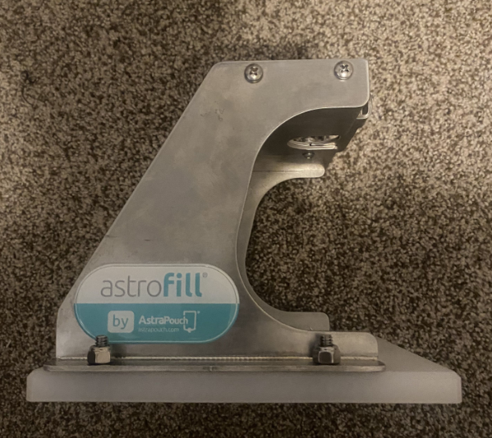

Figure 1: Side view of Astrofill

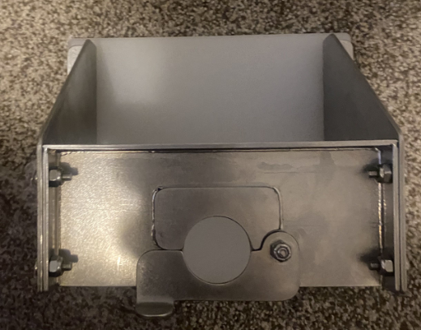

Figure 2: Overhead view of Astrofill

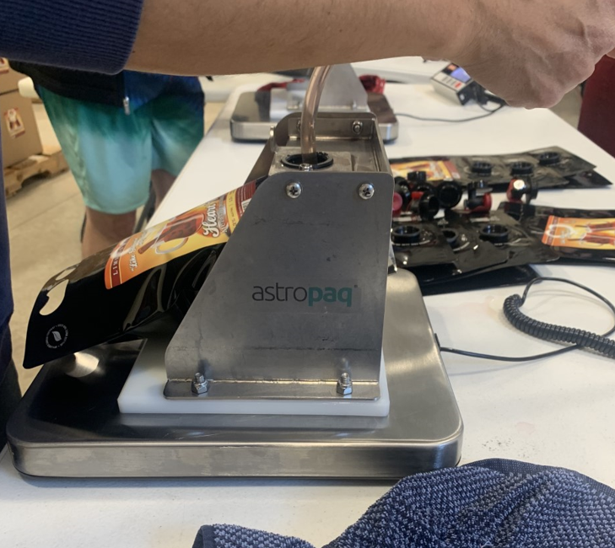

Figure 3: Astrofill in use

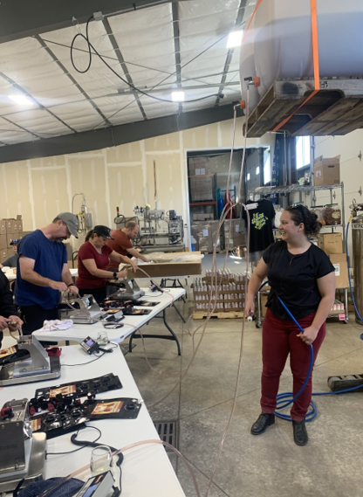

Figure 4: General view of table set-up including wine source on overhead forklift with tubes connecting down to each Astrofill device for filling